Content

Introduction 1

Prerequisites 1

Setup Github Repository 1

Login to Github 2

Create new Repository 2

Add Content to Your Repository 2

Create Website 3

Install and Setup Azure CLI 3

Configure Azure CLI 3

Create Web Site 4

(Optional) Deploy Git Branch 5

Basic Website Control Commands 5

List and Show Sites 5

Stop, Start, or Restart a Site 5

Delete a Site 5

Help on Sites 5

# Introduction

The purpose of this tutorial is to show the attendee how to set up a Windows Azure web site that uses github as source. It uses the cross-plattform CLI to setup the web site (the same operations can be performed in the browser dashboard as well).

## Prerequisites

To complete this tutorial, you need an Azure and a Github account as well as a git client for your platform.

# Setup Github Repository

The first step is to create a github repository. This will be used as source for the website. Content in this repository will be automatically published to your website.

## Login to Github

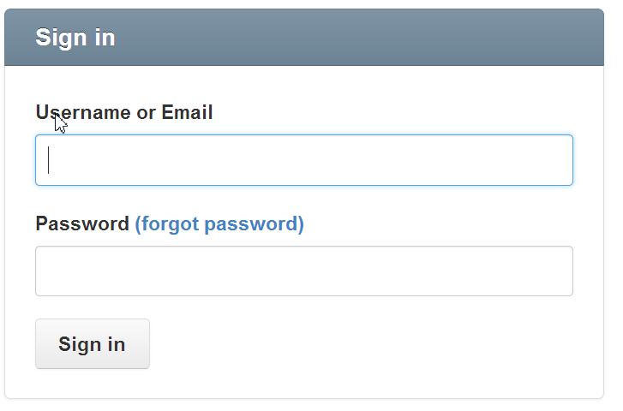First, sign in to your Github account at https://github.com/login:

## Create new Repository

Create a new repository with the button in the upper right corner:

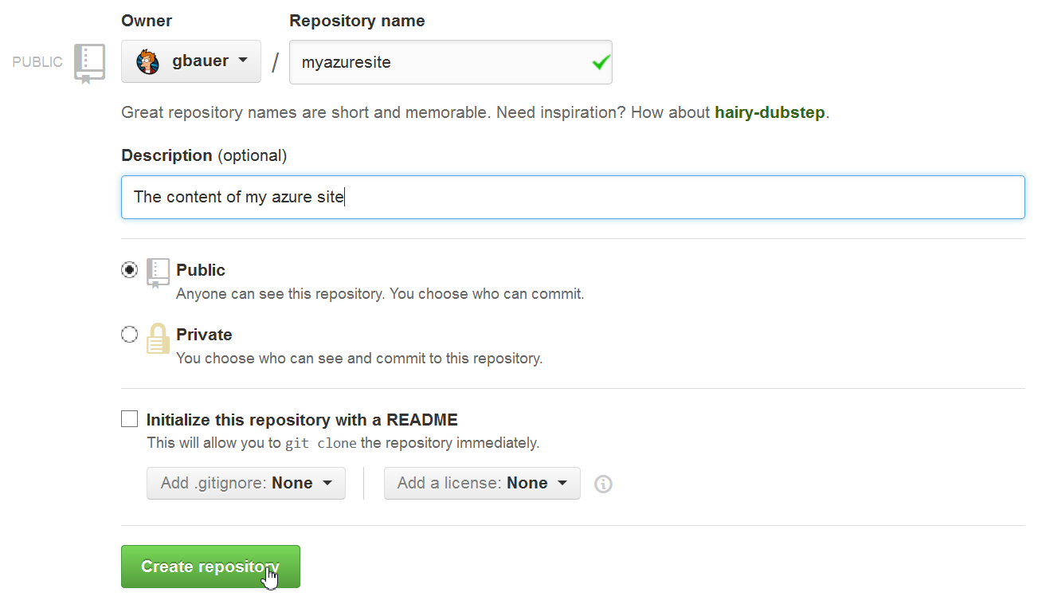Enter the repository name and an optional description:

## Add Content to Your Repository

Using your favorite git client, clone the repository on your local PC and then add content to it, for example the following HTML site (as index.html):

<html>

<head>

<title>My Github Azure Site</title>

</head>

<body>

<h1>This is my azure site connected to github</h1>

<p>Here I can place the content</p>

</body>

</html>

In the command line, use for example the following commands:

git clone git@github.com:username/reponame.git

# Create index.html with your text editor and the content from above

git add index.html

git commit –m “first upload of my site!”

git push

This will add your index.html page to your github repository and push it on the github server.

# Create Website

## Install and Setup Azure CLI

Install the Azure CLI from <http://www.windowsazure.com/en-us/manage/linux/how-to-guides/command-line-tools/> Please use the correct distribution for your OS:

## C:\Users\Gernot\Documents\projects\elastacloud\msr-courseware\repo\2. Getting Started with Virtual Machines and Websites\screenshots\b - build website with cli\01 download command line tools.pngConfigure Azure CLI

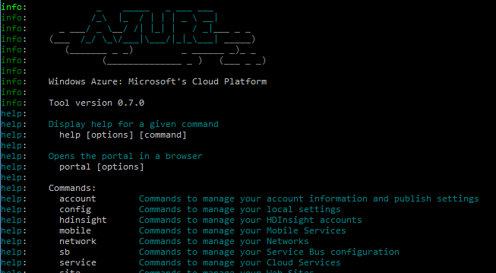After the installation of the azure CLI has succeeded, open up your console (Win+R, “cmd.exe”) or your shell and execute the “azure” command. You should see a welcome message and available program options that indicate that the CLI installation was successful:

Now you need to import the publish settings file that allows you to connect to your Azure subscription. To do this, execute the following command:

azure account download

This will open up a browser Window. Log in to your Azure account and download the publish settings file:

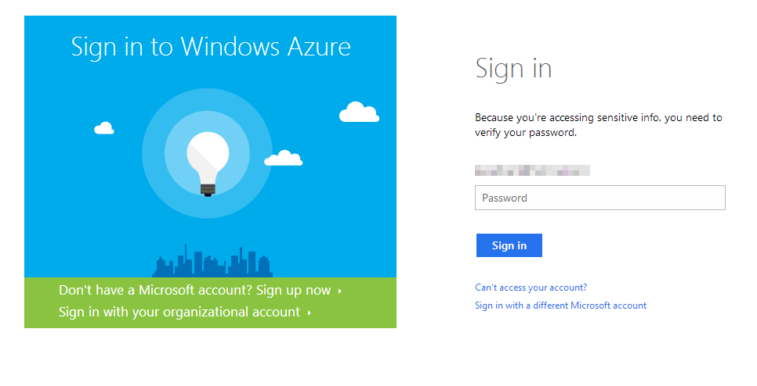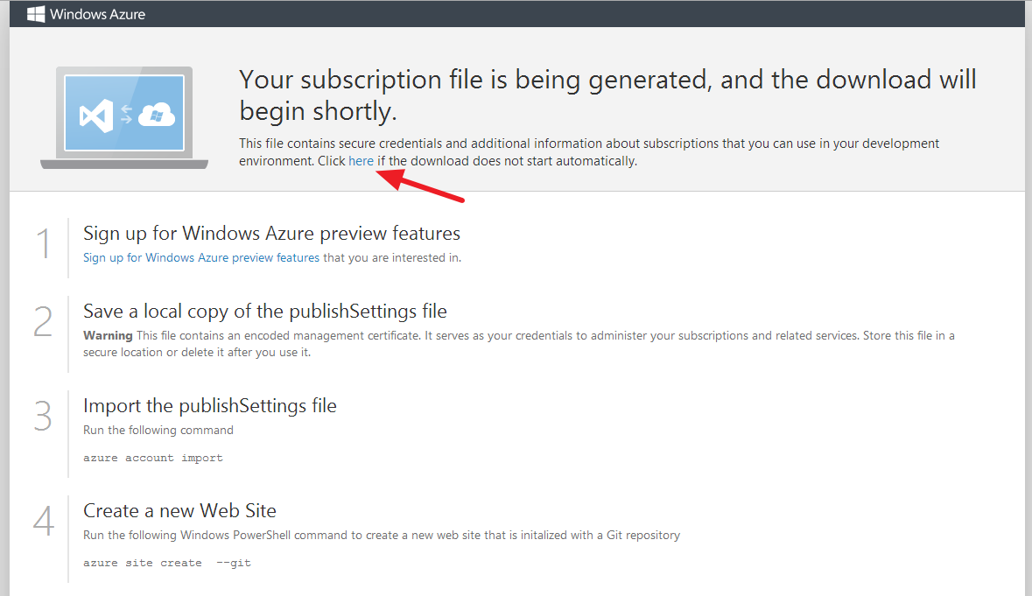Download the file to your local hard drive and remember its name and location.

In the next step, you need to import the settings file. Issue the following command in the console:

azure account import {.publishsettings file with path}

This will import your Azure accounts. Remember to use quotation marks for the file if it contains spaces.

Now your CLI is connected to your Azure subscriptions. If you have got more than one, issue the following command to set the correct subscription:

azure account set {account}

You can check your account names and the currently selected subscription with the following command:

azure account list

## Create Web Site

You are now ready to create the web site by using the following command:

azure site create MySite --github --githubusername username --githubpassword password --githubrepository githubuser/reponame

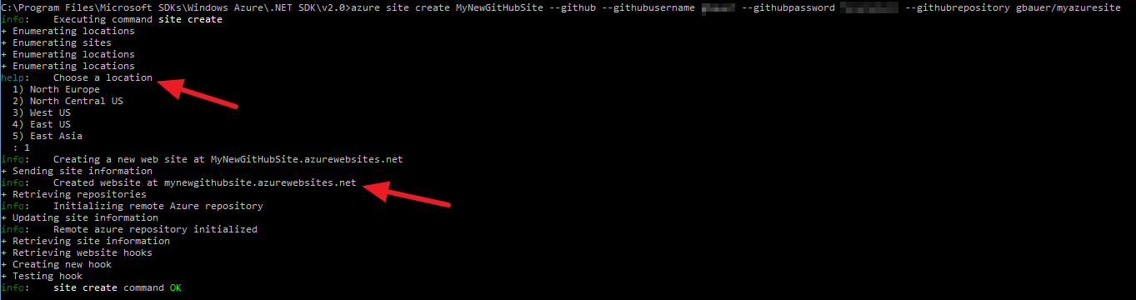Change “MySite” to the site name you want to use, username and password to your Github credentials and the Github repository you want to use. This will create your website:

The CLI will prompt you to choose the location you want to use. It then will create your website and install the necessary Github so that your page gets automatically deployed.

That’s it: Access your new web site with your browser to check if the deployment went ok:

## C:\Users\Gernot\Documents\projects\elastacloud\msr-courseware\repo\2. Getting Started with Virtual Machines and Websites\screenshots\b - build website with cli\05 test site.png(Optional) Deploy Git Branch

When you set up publishing from GitHub, the default branch used is the master branch. To specify a different branch, execute the following command from your local repository:

azure site repository branch <branch> <site>

# Basic Website Control Commands

## List and Show Sites

To list your web sites, use the following command:

azure site list

To get detailed information about a site, use the site show command. The following example shows details for MySite:

azure site show MySite

## Stop, Start, or Restart a Site

You can stop, start, or restart a site with the site stop, site start, or site restart commands:

azure site stop MySite

azure site start MySite

azure site restart MySite

## Delete a Site

Finally, you can delete a site with the site delete command:

azure site delete MySite

## Help on Sites

To see a complete list of site commands, use the -help option:

azure site –help